# Word Cloud

Expressions containing unnecessary characters and numbers in product comments have been deleted.

metin içeren bir resim

Açıklama otomatik olarak oluşturuldu

Figure 1.1.

The number of times each word was used was checked.

metin içeren bir resim

Açıklama otomatik olarak oluşturuldu

Figure 1.2.

A word cloud was created using a mask. A speech bubble was preferred because the comments were visualised.

metin içeren bir resim

Açıklama otomatik olarak oluşturuldu

Figure 1.3.

The words used in the comments are mostly words with positive connotations. This is an indication that customers are satisfied with the products they buy.

# Customer Segmentation by RFM

One of the most popular, easy-to-use, and effective segmentation methods to enable marketers to analyze customer behavior is RFM analysis. [RFM](https://clevertap.com/rfm/) stands for Recency, Frequency, and Monetary value, each corresponding to some key customer trait. These RFM metrics are important indicators of a customer’s behavior because frequency and monetary value affects a [customer’s lifetime value](https://clevertap.com/blog/customer-lifetime-value/), and recency affects retention, a measure of engagement.

RFM factors illustrate these facts:

* the more recent the purchase, the more responsive the customer is to promotions
* the more frequently the customer buys, the more engaged and satisfied they are
* monetary value differentiates heavy spenders from low-value purchasers

RFM values were calculated for each customer.

tablo içeren bir resim

Açıklama otomatik olarak oluşturuldu

Figure 2.1.

**Frequency** and **Recency** is low because the products sold by the company are products that are used for a long time, such as carpets. For example, you can’t expect a customer to purchase a rug on a monthly basis. In this case, a marketer could give more weight to **Monetary** and **Recency** aspects rather than. Therefore, we will not use **Frequency** scores when calculating the RFM score. Instead, customers with a Frequency value greater than 1 were included in the analysis.

tablo içeren bir resim

Açıklama otomatik olarak oluşturuldu

Figure 2.2.

tablo içeren bir resim

Açıklama otomatik olarak oluşturuldu

Figure 2.3.

According to RFM scores, customers were divided into 10 different segments.

These are *can’t loose them, loyal customers, champions, at risk, need attention, potential loyalists, hibernating, about to sleep, promising*and*new customers.*

tablo içeren bir resim

Açıklama otomatik olarak oluşturuldu

Figure 2.4.

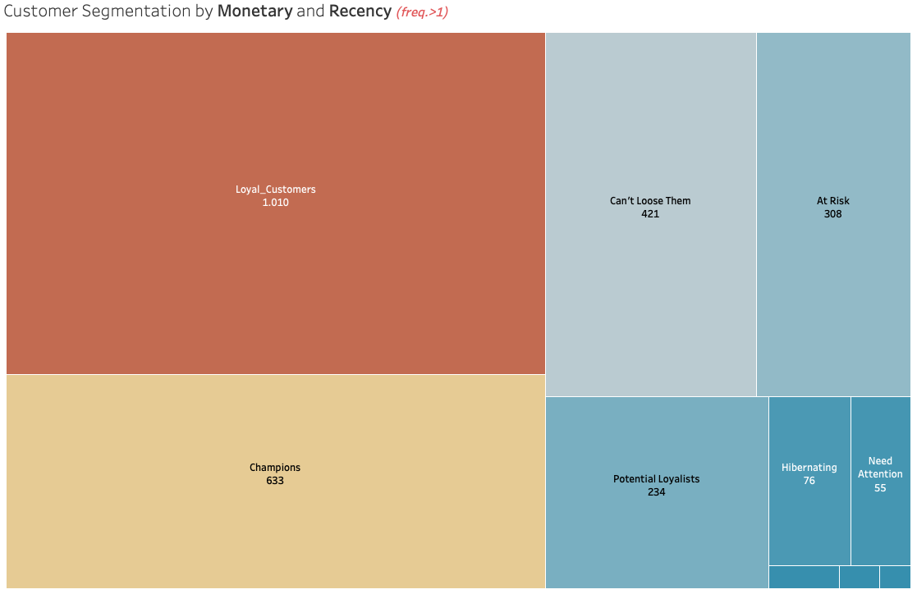

Figure 2.5.

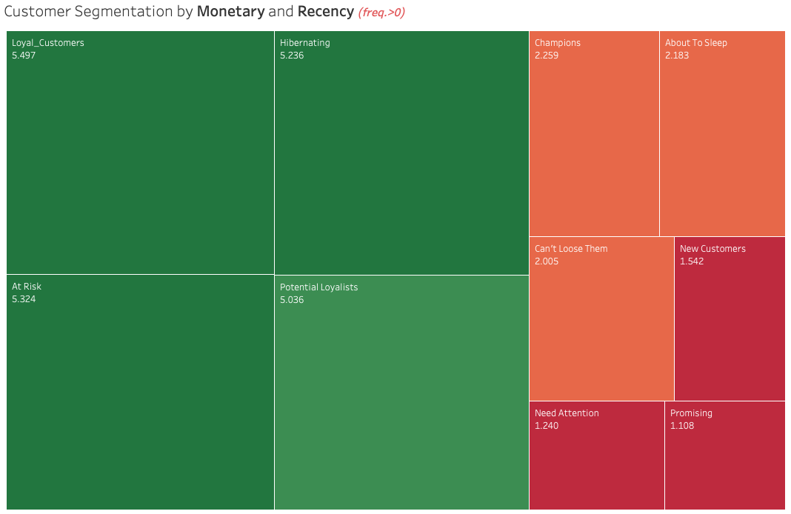

Figure 2.6.

All customers are included in the final picture.

Recommendations

**Champions** are your best customers, who bought most recently, most often, and are heavy spenders. Reward these customers. They can become early adopters for new products and will help promote your brand.

**Potential Loyalists** are your recent customers with average frequency and who spent a good amount. Offer membership or loyalty programs or recommend related products to upsell them and help them become your Loyalists or Champions.

**New Customers** are your customers who have a high overall RFM score but are not frequent shoppers. Start building relationships with these customers by providing onboarding support and special offers to increase their visits.

**At Risk Customers** are your customers who purchased often and spent big amounts, but haven’t purchased recently. Send them personalized reactivation campaigns to reconnect, and offer renewals and helpful products to encourage another purchase.

**Can’t Lose Them** are customers who used to visit and purchase quite often, but haven’t been visiting recently. Bring them back with relevant promotions, and run surveys to find out what went wrong and avoid losing them to a competitor.